FACULTY EVALUATION
Programme Name: Social Entrepreneurship Program (SEP)- START MASTERCLASS Uganda (26th January 2026 - 30th January 2026)
Session: Reflect on Vision and Mission/ Reflect on charism/ Identify alignment to social enterprise
Faculty Name: Dr. Joan Wanjiku Ndung'u - Gitahi
No. of Respondents: 12
No. of Participants: 12
Evaluation Parameter | (%) Individual Score | (%) Programme Average
Punctuality (Commencement and Completion of Sessions) | 80 | 88
How well do you understand the core concepts presented? | 85 | 83
Rate your confidence in applying the new skills learnt | 78 | 78
Degree of Faculty preparedness for the sessions | 93 | 91
Content and methodology of the program | 87 | 87
Quality of class and group discussions | 82 | 82
The information presented in the course is relevant to my work (ministry) | 88 | 91
Average scores | 85 | 86

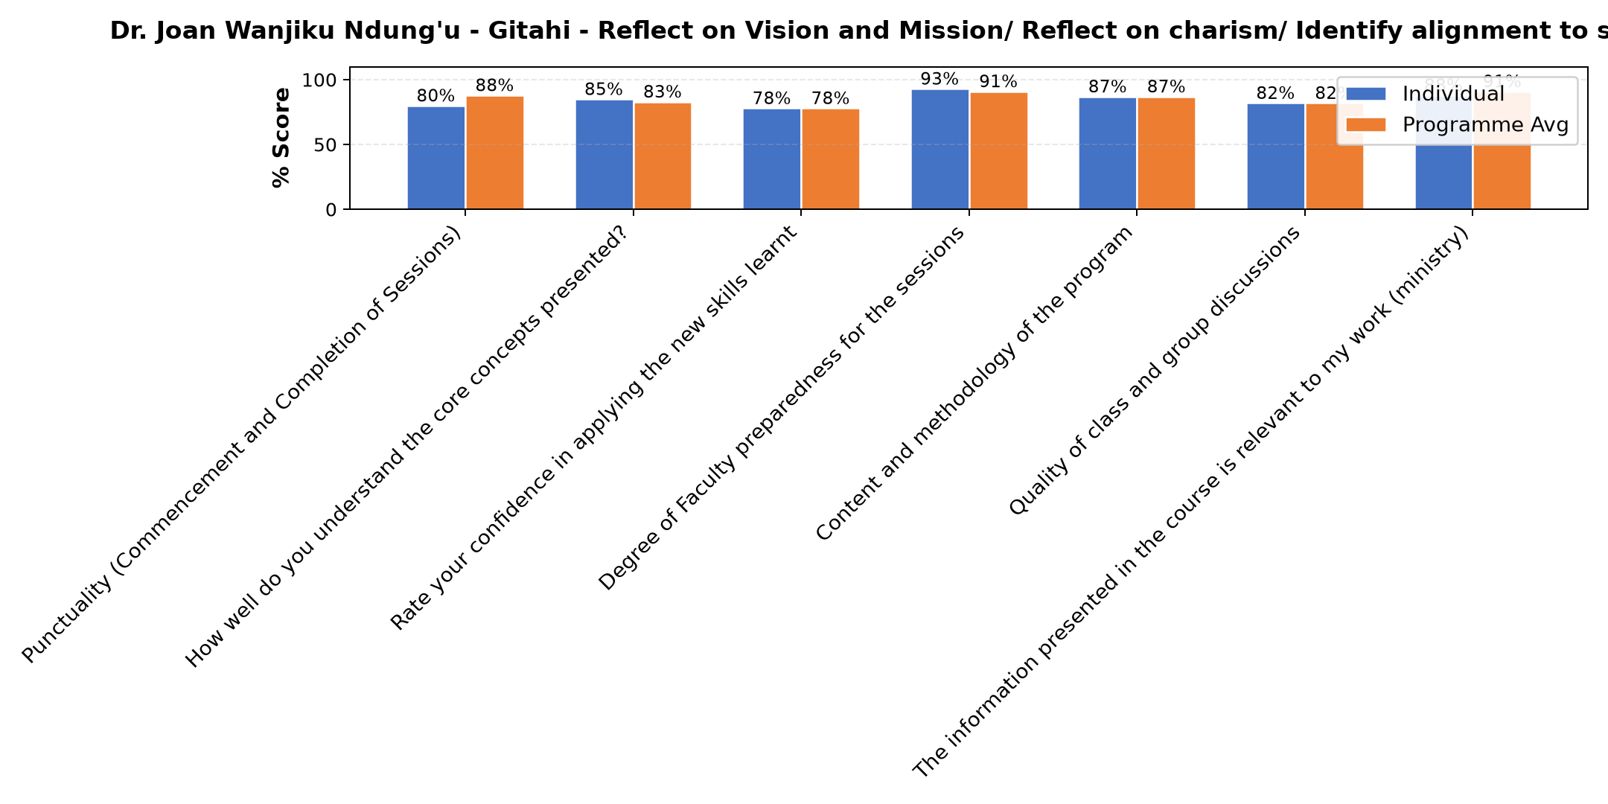

Comments & Feedback
- • Limited finances to carter for the targeted population
- • Lack of facilities like ours social enterprise we lacking the matinity ward and children's ward.
- • I went back for furthur studies
- • I went back for further studies
- • Absence on the ground
- • Organizational challenges. I could not concentrate since I was requested to go back to school
- • Transfer
- • Not operating that particular enterprise as a leader
SUBMITTED THROUGH:
SBS Evaluation Automation System

